Managing an event effectively involves careful planning, meticulous organization, and seamless execution. It all starts with clearly defining the purpose and goals of the event, which sets the direction for every subsequent decision. From selecting the right venue and date to crafting an engaging program and promoting it effectively, every detail matters in creating a successful event experience. Budgeting plays a crucial role in allocating resources wisely, ensuring that expenses are balanced against anticipated returns.

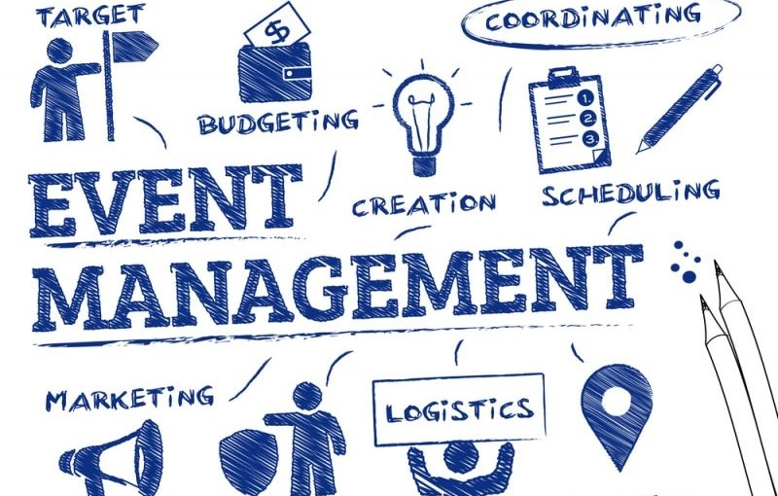

Once the groundwork is laid, attention turns to the logistical aspects of the event. Coordinating vendors, arranging equipment, and handling registrations all require careful management to ensure everything comes together smoothly on the day of the event. Staff and volunteers need to be briefed and prepared to handle their roles, whether it's greeting guests, managing technical setups, or providing assistance throughout the event. Additionally, safety and security measures must be in place to safeguard attendees and maintain the integrity of the event.

On the day of the event, the focus shifts to execution. With all preparations in place, the event manager oversees the proceedings, addressing any last-minute issues that arise and ensuring that everything proceeds according to plan. Effective communication and quick problem-solving are key skills in managing unforeseen challenges and keeping the event on track. Finally, after the event concludes, gathering feedback from participants helps to evaluate its success and identify areas for improvement, ensuring that future events continue to meet the needs and expectations of attendees.